**rpm包下载地址：**

**链接: https://pan.baidu.com/s/1SZjApFzZ2PHHSeUbg7xRfw 提取码: q3r8**

**参考：**<https://www.cnblogs.com/xiaxiaoxu/p/9978976.html>

**数据库包下载：**

[**https://www.mysql.com/downloads/**](https://www.mysql.com/downloads/)

**在GPL开原协议的社区开源版里边下载**

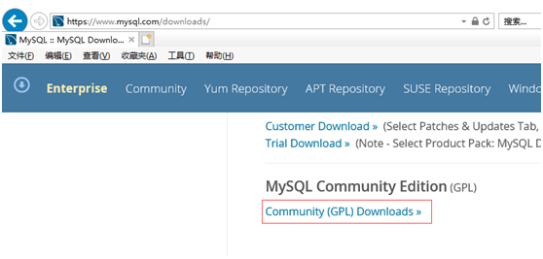

**我们用mysql community server里边的**

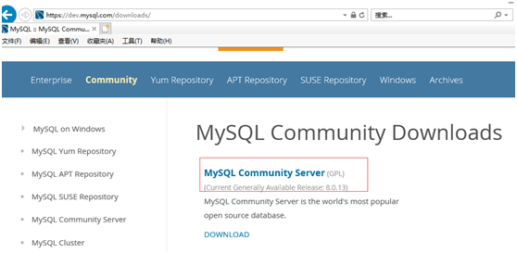

其中workbench是客户端工具



MySQL Cluster是oracle自己搞的集群版的（集成了一些开源工具和增值服务）

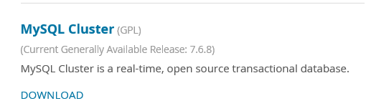

**选择操作系统和版本**

建议在linux下安装

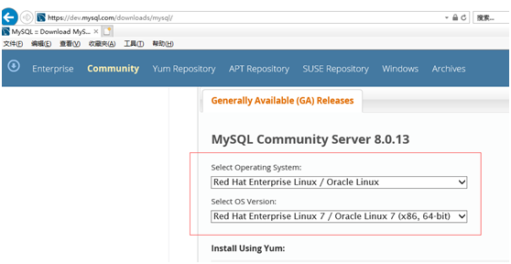

**也可以选择版本**

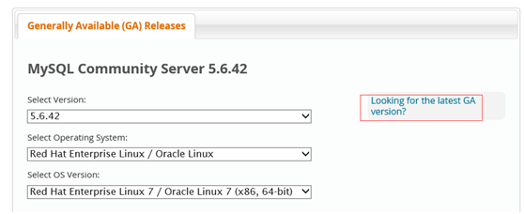

**下载server包和client包**

如果是server包，那架构图里的东西都有了

还要下个client utilities包，客户端包，类似connection层

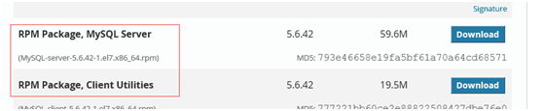

**下载后用rz命令传到centos linux系统里边**

rpm是包管理器

xshell可以直接拖

也可以用rz命令，没有的话安装一下： yum install lrzsz

yum是包资源管理器，可以解决包依赖的问题，把需要的包都下载下来

传到linux系统

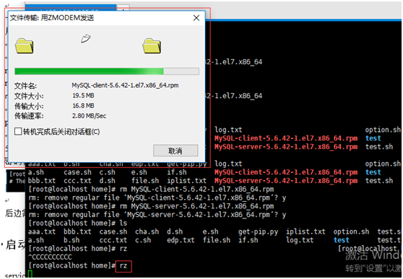

**安装mysql步骤：**

**清理环境**

centos7会自带一个mariadb

查看是否已安装

rpm -qa |grep -i mysql

rpm -qa |grep -i mariadb（centos7默认系统自带的）

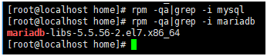

mariadb是从mysql来的，是它的一个分支，需要清理掉

清理掉mariadb包

用yum直接安装你的话，用的mariadb的yum源，它跟mysql官方正式版不太一样，我们要安装官方正式版，就需要清掉mariadb，然后手动安装自己下载的官方正式版mysql

**rpm -e 加上包名，把mariadb包清掉**

可以看到用rpm删除会失败，提示有依赖关系的软件需要安装

rpm -e mariadb-libs-5.5.56-2.el7.x86_64

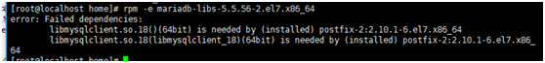

**rpm删除时如果有依赖关系，可以用yum remove + 包名来删除mariadb**

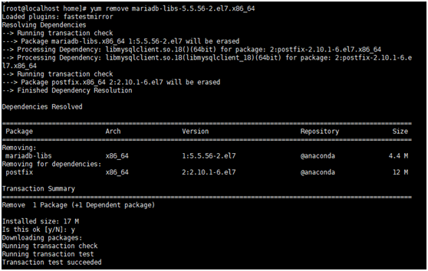

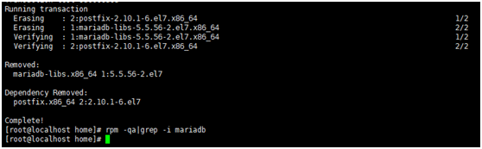

**开始安装:**

一般用装软件用yum直接安装也可以，但是有一个问题：用yum的话，是到默认的mariadb用的yum源去找，可能会找不到，所以我们自己来安装

rpm –ivh + 包安装所需要的包

**rpm -ivh MySQL-client-5.6.42-1.el7.x86_64.rpm**

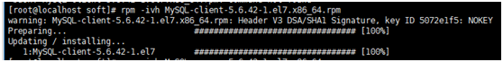

**rpm -ivh MySQL-server-5.6.42-1.el7.x86_64.rpm**

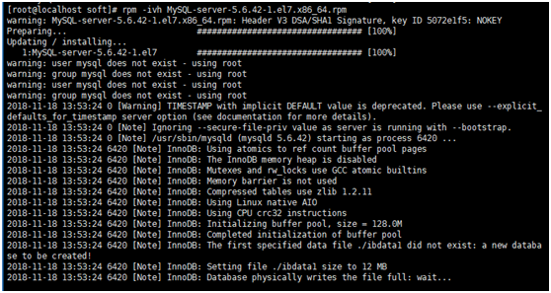

**server安装成功后会输出一些信息，如下：**

[root@localhost soft]# rpm -ivh MySQL-server-5.6.42-1.el7.x86_64.rpm

warning: MySQL-server-5.6.42-1.el7.x86_64.rpm: Header V3 DSA/SHA1 Signature, key ID 5072e1f5: NOKEY

Preparing...                          ################################# [100%]

Updating / installing...

   1:MySQL-server-5.6.42-1.el7        ################################# [100%]

warning: user mysql does not exist - using root

warning: group mysql does not exist - using root

warning: user mysql does not exist - using root

warning: group mysql does not exist - using root

2018-11-18 13:53:24 0 [Warning] TIMESTAMP with implicit DEFAULT value is deprecated. Please use --explicit_defaults_for_timestamp server option (see documentation for more details).

2018-11-18 13:53:24 0 [Note] Ignoring --secure-file-priv value as server is running with --bootstrap.

2018-11-18 13:53:24 0 [Note] /usr/sbin/mysqld (mysqld 5.6.42) starting as process 6420 ...

2018-11-18 13:53:24 6420 [Note] InnoDB: Using atomics to ref count buffer pool pages

2018-11-18 13:53:24 6420 [Note] InnoDB: The InnoDB memory heap is disabled

2018-11-18 13:53:24 6420 [Note] InnoDB: Mutexes and rw_locks use GCC atomic builtins

2018-11-18 13:53:24 6420 [Note] InnoDB: Memory barrier is not used

2018-11-18 13:53:24 6420 [Note] InnoDB: Compressed tables use zlib 1.2.11

2018-11-18 13:53:24 6420 [Note] InnoDB: Using Linux native AIO

2018-11-18 13:53:24 6420 [Note] InnoDB: Using CPU crc32 instructions

2018-11-18 13:53:24 6420 [Note] InnoDB: Initializing buffer pool, size = 128.0M

2018-11-18 13:53:24 6420 [Note] InnoDB: Completed initialization of buffer pool

2018-11-18 13:53:24 6420 [Note] InnoDB: The first specified data file ./ibdata1 did not exist: a new database to be created!

2018-11-18 13:53:24 6420 [Note] InnoDB: Setting file ./ibdata1 size to 12 MB

2018-11-18 13:53:24 6420 [Note] InnoDB: Database physically writes the file full: wait...

2018-11-18 13:53:24 6420 [Note] InnoDB: Setting log file ./ib_logfile101 size to 48 MB

2018-11-18 13:53:25 6420 [Note] InnoDB: Setting log file ./ib_logfile1 size to 48 MB

2018-11-18 13:53:25 6420 [Note] InnoDB: Renaming log file ./ib_logfile101 to ./ib_logfile0

2018-11-18 13:53:25 6420 [Warning] InnoDB: New log files created, LSN=45781

2018-11-18 13:53:25 6420 [Note] InnoDB: Doublewrite buffer not found: creating new

2018-11-18 13:53:25 6420 [Note] InnoDB: Doublewrite buffer created

2018-11-18 13:53:25 6420 [Note] InnoDB: 128 rollback segment(s) are active.

2018-11-18 13:53:25 6420 [Warning] InnoDB: Creating foreign key constraint system tables.

2018-11-18 13:53:25 6420 [Note] InnoDB: Foreign key constraint system tables created

2018-11-18 13:53:25 6420 [Note] InnoDB: Creating tablespace and datafile system tables.

2018-11-18 13:53:25 6420 [Note] InnoDB: Tablespace and datafile system tables created.

2018-11-18 13:53:25 6420 [Note] InnoDB: Waiting for purge to start

2018-11-18 13:53:25 6420 [Note] InnoDB: 5.6.42 started; log sequence number 0

A random root password has been set. You will find it in '/root/.mysql_secret'.

2018-11-18 13:53:26 6420 [Note] Binlog end

2018-11-18 13:53:26 6420 [Note] InnoDB: FTS optimize thread exiting.

2018-11-18 13:53:26 6420 [Note] InnoDB: Starting shutdown...

2018-11-18 13:53:27 6420 [Note] InnoDB: Shutdown completed; log sequence number 1625977

2018-11-18 13:53:27 0 [Warning] TIMESTAMP with implicit DEFAULT value is deprecated. Please use --explicit_defaults_for_timestamp server option (see documentation for more details).

2018-11-18 13:53:27 0 [Note] Ignoring --secure-file-priv value as server is running with --bootstrap.

2018-11-18 13:53:27 0 [Note] /usr/sbin/mysqld (mysqld 5.6.42) starting as process 6444 ...

2018-11-18 13:53:27 6444 [Note] InnoDB: Using atomics to ref count buffer pool pages

2018-11-18 13:53:27 6444 [Note] InnoDB: The InnoDB memory heap is disabled

2018-11-18 13:53:27 6444 [Note] InnoDB: Mutexes and rw_locks use GCC atomic builtins

2018-11-18 13:53:27 6444 [Note] InnoDB: Memory barrier is not used

2018-11-18 13:53:27 6444 [Note] InnoDB: Compressed tables use zlib 1.2.11

2018-11-18 13:53:27 6444 [Note] InnoDB: Using Linux native AIO

2018-11-18 13:53:27 6444 [Note] InnoDB: Using CPU crc32 instructions

2018-11-18 13:53:27 6444 [Note] InnoDB: Initializing buffer pool, size = 128.0M

2018-11-18 13:53:27 6444 [Note] InnoDB: Completed initialization of buffer pool

2018-11-18 13:53:27 6444 [Note] InnoDB: Highest supported file format is Barracuda.

2018-11-18 13:53:27 6444 [Note] InnoDB: 128 rollback segment(s) are active.

2018-11-18 13:53:27 6444 [Note] InnoDB: Waiting for purge to start

2018-11-18 13:53:27 6444 [Note] InnoDB: 5.6.42 started; log sequence number 1625977

2018-11-18 13:53:27 6444 [Note] Binlog end

2018-11-18 13:53:27 6444 [Note] InnoDB: FTS optimize thread exiting.

2018-11-18 13:53:27 6444 [Note] InnoDB: Starting shutdown...

2018-11-18 13:53:29 6444 [Note] InnoDB: Shutdown completed; log sequence number 1625987

**A RANDOM PASSWORD HAS BEEN SET FOR THE MySQL root USER !**

**You will find that password in '/root/.mysql_secret'.**

You must change that password on your first connect,

no other statement but 'SET PASSWORD' will be accepted.

See the manual for the semantics of the 'password expired' flag.

Also, the account for the anonymous user has been removed.

In addition, you can run:

  /usr/bin/mysql_secure_installation

which will also give you the option of removing the test database.

This is strongly recommended for production servers.

See the manual for more instructions.

Please report any problems at http://bugs.mysql.com/

The latest information about MySQL is available on the web at

  http://www.mysql.com

Support MySQL by buying support/licenses at http://shop.mysql.com

WARNING: Found existing config file /usr/my.cnf on the system.

Because this file might be in use, it was not replaced,

but was used in bootstrap (unless you used --defaults-file)

and when you later start the server.

The new default config file was created as /usr/my-new.cnf,

please compare it with your file and take the changes you need.

**其中有两句指明mysql安装时给root设置了一个随机的初始密码：**

密码的位置放在**'/root/.mysql_secret'文件中**

用于第一次登陆mysql时使用的，登陆之后会强制修改一下

**A RANDOM PASSWORD HAS BEEN SET FOR THE MySQL root USER !**

**You will find that password in '/root/.mysql_secret'.**

You must change that password on your first connect,

no other statement but 'SET PASSWORD' will be accepted.

See the manual for the semantics of the 'password expired' flag.

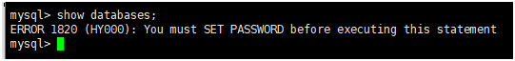

**查看该文件，可以看到我在重装mysql时新生成一个随机密码**

https://img2018.cnblogs.com/blog/1214695/201811/1214695-20181118193037345-1123591575.png

**ps –ef|grep –i mysql 看是否有mysql进程**

https://img2018.cnblogs.com/blog/1214695/201811/1214695-20181118193046524-535399078.png

用rpm –qa |grep –I mysql看下mysql是否安装成功了，看到两个mysql的组件，就是安装成功了

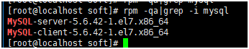

5.6以后要设置一个root账号的随机密码

密码保存到root/.mysql_secret文件里

https://img2018.cnblogs.com/blog/1214695/201811/1214695-20181118193102645-1786275205.png

后边需要用这个初始的密码登录mysql

**启动服务：service mysql start**

https://img2018.cnblogs.com/blog/1214695/201811/1214695-20181118193113607-1861509433.png

**ps –ef |grep mysql 看有没有mysql服务**

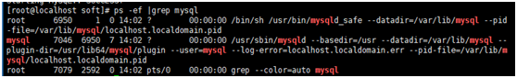

**登录数据库：**

mysql –uroot –p 敲回车

然后输入随机密码

登录后，提示一些信息

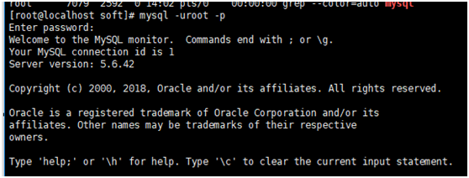

如连接线程id、版本什么的

**show databases; 查看数据库有哪些库**

在使用前要设置一个自己的密码

会要求重置随机密码



**重置密码方法：set password=password(‘root’);**

是给当前用户设置密码为root

https://img2018.cnblogs.com/blog/1214695/201811/1214695-20181118193158416-1318020610.png

**再运行 show databases;**

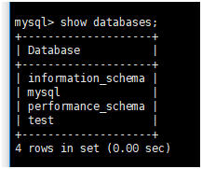

**mysql会自带一些系统库：**

information_schema存一些统计数据

performance_schema存一些状态数据，

mysql存的数据用于监控、权限、账号等

test是测试库，用于做测试用的

如果重新安装，数据目录没变的话，那么之前的库还是存在的